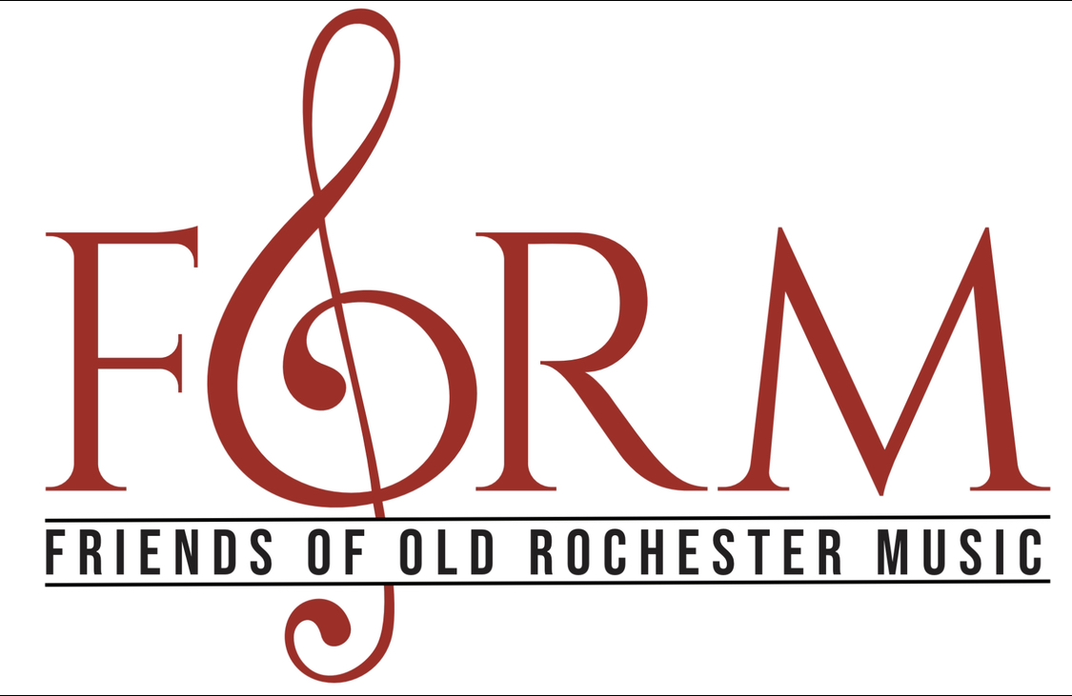
2024 Scholarship AWARD Application

Eligibility:
Applicant must have fully participated in the music program at the Old Rochester Regional High School by having been officially enrolled in academic music courses for at least four full years (full participation in an academic music course(s) at the Old Rochester Regional Junior High School program may also be included in this minimum “4 year total” requirement).

Applicant’s Full Name: _______________________________________________
Address: ____________________________________________________________
E-mail: ______________________________________________________________
Parent/Guardian e-mail: ______________________________________________
Institution you will be attending in Fall of 2024 & intended major (if applicable) : _________________________________________________________

Additional Requirements (please include your full name on each page):

● Music Resume: On a separate page, please list the following music related information:

1) ORR Music Program(s) (i.e. Chorus, Concert Band, Jazz Band, A Capella) Please indicate the year(s) of academic music course enrollment, as well as, year(s) of involvement for each musical group, activity, and experience. (should be a minimum of 4 years) *If you participated in music programs at the JHS level, please indicate programs and years of participation, these count!

2) ORR musical activities you participated in while you were enrolled in ORRHS Music Program (i.e. Drama pit orchestra, FORM Fundraisers, Districts/All State etc)

3) Offices held, achievements, honors, special recognitions, summer experiences and other community music program involvement, (i.e. Southcoast Children’s Chorus, SEMAYO, RIPYO, Tri—Town Symphonic Band, Town Summer bands, etc). Please indicate the date(s) and/or year(s)

● Essay: On a separate page, in 250 words please describe how your musical experiences in the ORR music program(s) have added value and significance to your high school experience. Please indicate your consent allowing FORM to utilize portion(s) of your essay for testimonial purposes here: YES or NO

Signature of Applicant: ________________________Date: _____________

Please submit PDF files via email to FORM@OldRochester.org
FORM will respond letting you know that your application is received.
Application due by May 1st, 2024

